Chapter 2
Knowledge Exercise Answers

- The built in structure array supports the fetch and update operations.

500
504
508
512
516
numbers
0
3
2
1
4

- Address of element k = A_{o} + k * w = 500 + k * 4

- a) and b)
 | 0 | 1 | 2 | 3 | 4
0
1
2 |  |  |  | x
3

c) Address of ages[2][3] = A_{o} + (i * (j_{max} + 1) + j) * w = 500 + (2 * (4 + 1) + 3)*4 = 552

- The new line 7 would be: return data[i];

- The Sorted Array would be best for this structure, because only Fetch operations will be performed and this structures Fetch operation is the fastest, O(log₂n).

- When all four basic operations are equally probable the Unsorted Optimized Array is faster than the Sorted Array structure because, although the binary search speeds up the Fetch operation of the Sorted Array structure, having to keep the nodes in sorted order slows down its Insert and Delete operations to the point were its average operation speed is a bit slower than that of the Unsorted Optimized Array structure.

- Location 300 would be returned.

- The Unsorted-Optimized structure used modified Fetch and Delete algorithms. When a node was fetched from the optimized structure, its reference was swapped with the node reference just above it in the array. Thus, the references to the nodes most frequently accessed become positioned near the top of the array speeding up the sequential search. When a node was deleted, instead of moving all the references up one location in the array, the reference to the deleted node was overwritten with the last node reference stored in the array. If all nodes have equal probability of being accessed, the speed of the Fetch operation of the two structures is equivalent.

- a) Density = 1 / (1 + 4 / w + 4 / (w * n) = 1 / (1 + 4 / 8 + 4 / 8 * 50) = 1 / 1.51 = 0.662
b) Density = 1 / (1 + 4 / w + 4 / (w * n) = 1 / (1 + 4 / 200 + 4 / 1,000,000*200)
= 1 / 1.02 = 0.98

- a) The average number of memory accesses ≤ (3n + 6) / 4 = (3,000,000 + 6) / 4 = 750,002
memory accesses.
b) The average number of memory accesses = 3.

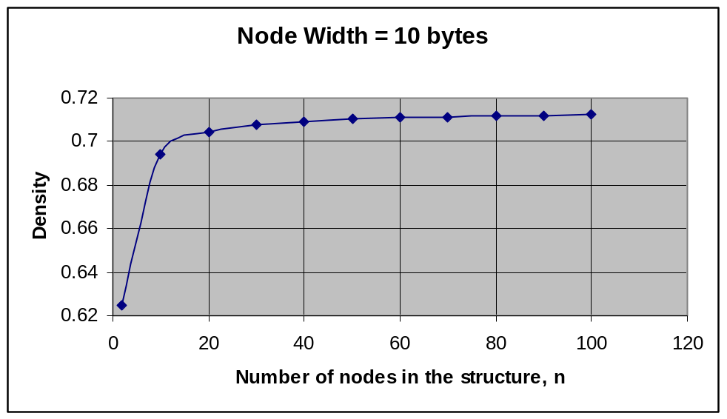

- The term “garbage collection” is the process by which a data structure reuses the storage assigned to deleted nodes, or the process of returning the storage of deleted nodes to the operating system’s memory manager.

- The garbage collection method for the Unsorted-Optimized array structure is to decrement the variable next after overwriting the reference to the deleted node with the last node reference. This causes the reference to the next node inserted into the structure to reuse the array element previously used to store the last node reference.

- The speed of the Fetch operations performed on the structure will improve as the structure is used if there are some nodes in the structure that are fetch more frequently than others.

- The data set is heterogeneous (non-homogeneous).

- 1- The node definition and the data structure are coded as two separate classes.
2- The data structure cannot mention the names of the data fields that make up a node.
3- If the structure is going to be encapsulated, a method to perform the deep copy of a node must be coded in the node definition class.
4- If the structure is going to be accessed in the key field mode, a method to determine if a given key is equal to the key of a node must be coded in the node definition class.
5- The data structure code cannot mention the name of the node class.
6- Any key field type should be valid.

- / / access the node (assumes the node is in the structure)
- i = 0;
- while (targetKey != data[i].key( ))
- { i++;
- }
- / / overwrite the reference to the node with a reference to a deep copy of the new contents
- data[i] = newNode.deepCopy();

